PHIPA Compliance for Log360
Strengthen data protection and meet PHIPA compliance with Log360.
Region: Canada | Type: Data Privacy, Healthcare | Category: Compliance | Pricing: Free

Overview
The PHIPA compliance extension in Log360 helps organizations meet the Personal Health Information Protection Act (PHIPA), Ontario's provincial health privacy law governing PHI collection, use, and disclosure by hospitals, physicians, pharmacies, and laboratories under S.O. 2004 Chapter 3 by providing centralized log management, audit log monitoring, and breach detection capabilities. The platform supports PHIPA requirements for PHI access control, electronic audit logs, breach detection, agent and service provider access, PHI data handling, third-party disclosure auditing, and privileged account management.
For PHI Access Control and Authentication, Log360 monitors Windows and Active Directory logon events, failed authentication attempts, Entra ID user logon, risky sign-in alerts, and MFA enforcement to ensure only authorized health professionals access PHI systems. To address Electronic Audit Log Monitoring, the platform captures Windows event logs, system events, process tracking, database server audit records, and Oracle and SQL Server auditing to provide the complete PHI access trail required by the Act. The extension also supports Privacy Breach Detection and Notification by providing capabilities that integrates FireEye, Trend Micro, McAfee, Windows Threat Detection, and cloud storage security incident reports to detect PHI breaches and support the mandatory notification process.

Key Features
- Agent and Service Provider Access Management: Log360 monitors user and group account changes, Active Directory user management, Entra ID role assignments, and directory management to audit all agent and service provider access to PHI systems.
- PHI Data Handling and Storage Security: Log360 monitors file changes, file permission reports, failed file access attempts, Windows USB storage auditing, and SharePoint and OneDrive file activities to detect PHI mishandling.
- PHI Disclosure and Third-Party Access Audit: Log360 monitors Exchange mailbox activity, mailbox permission changes, Exchange Online mailflow, OneDrive sharing, and cloud storage integration events to track all PHI disclosure activities.
- Privileged Access Management for PHI Systems: Log360 monitors Unix SUDO commands, Unix account management, Active Directory password auditing, policy changes, and GPO auditing to control and audit privileged access to PHI-containing systems.


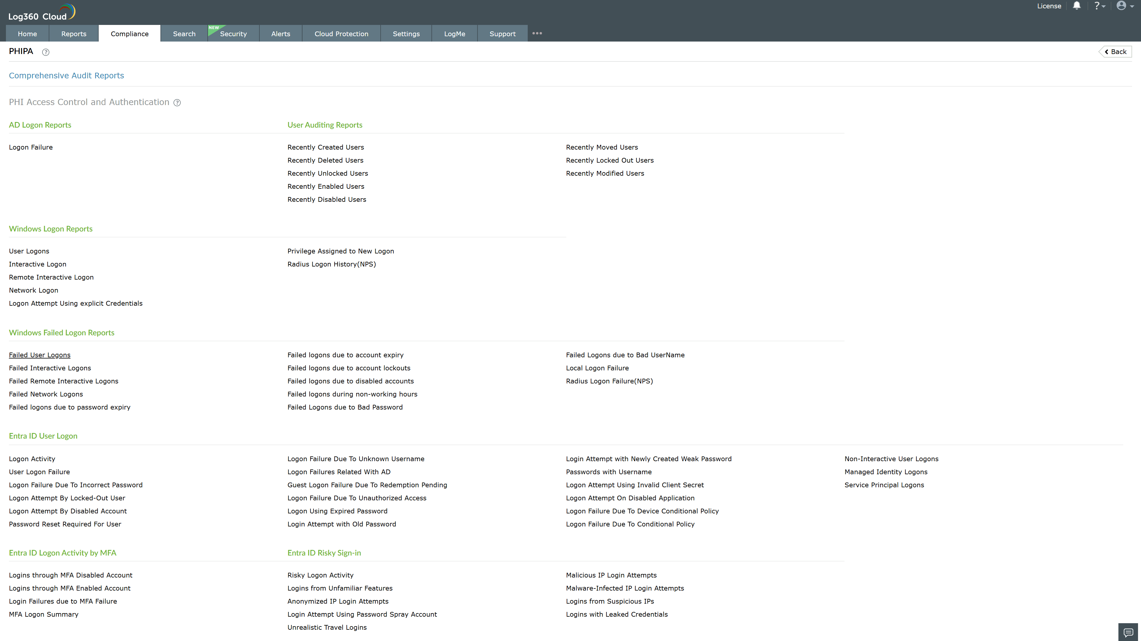
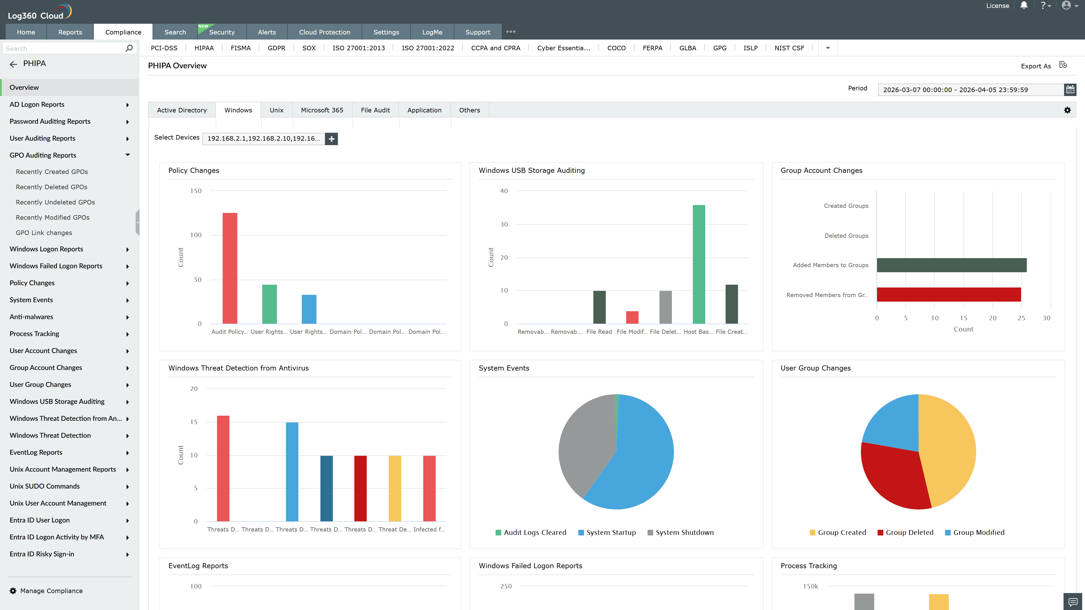
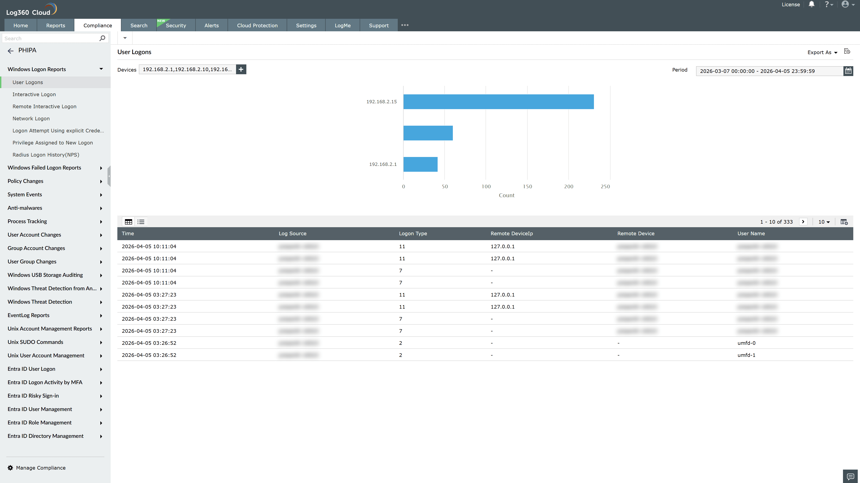
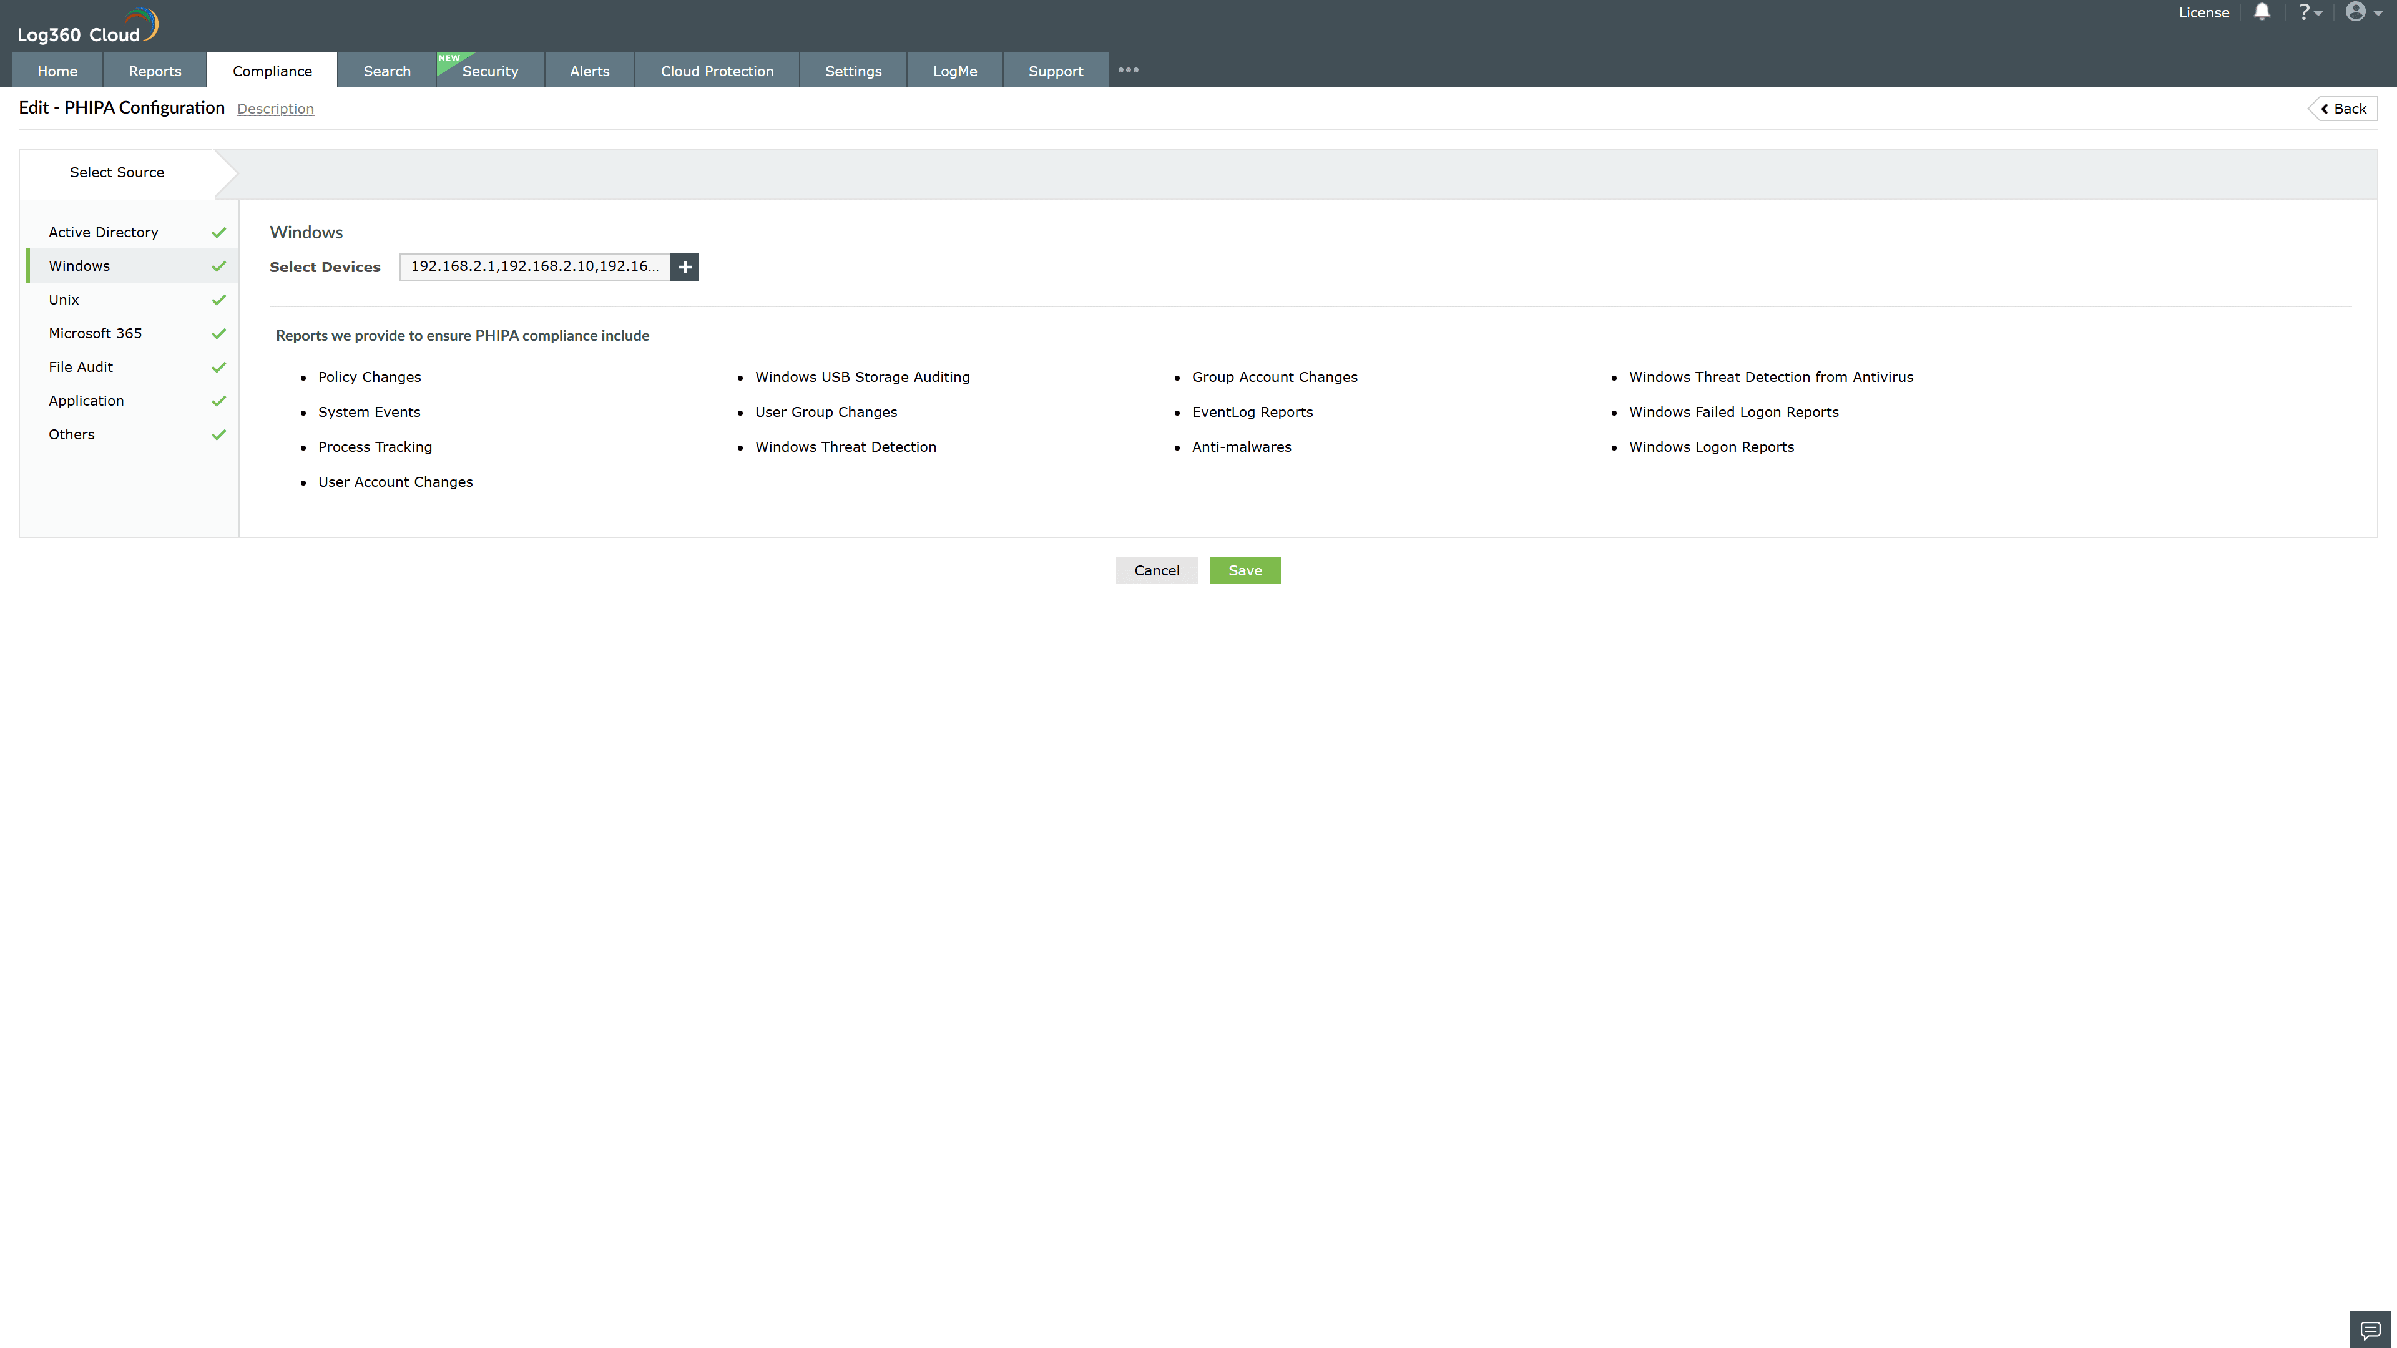
Valid Submission : Yes
Supported Editions : Free, Basic, Standard, Professional, MSSP
Help Document : https://www.manageengine.com/log-management/help/integrations/compliance-extensions.html
Help Video : Not provided
Tags : Log360, Compliance, Privacy monitoring, Data privacy, Regulatory compliance
Supported DCs : US, IN, JP, CA, AU, UK and EU
Privacy Policy:
Terms of Service:
Release Notes:
Predefined reports for the PHIPA.

